Step-by-Step Instructions for Registering for Classes using VIC
Go to NSU home page (www.nsula.edu.)
Click on the “myNSU” link (beginning Summer 2026, “VIC” will replace “myNSU”)
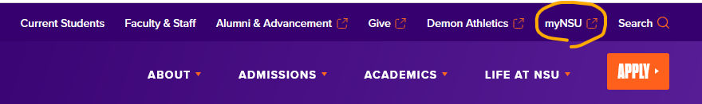

Signing In
  - First time user:
    - Username: NSU student email address, which is your first initial + up to 13 characters of last name + the last 6 digits of your Campus Wide ID (CWID) followed by “@nsula.edu”
      - Example: Victor Demon (whose student ID number is 200123456) would have the username “vdemon123456@nsula.edu”
    - Initial password: Demons + your six-digit date of birth
      - Example: If your birthdate is 12-01-2005, then your initial password will be “Demons120105”
  - NOTE: To retrieve your CWID, please click the following link: Find Your CWID
If you need additional assistance, please contact the Student Help Desk at (318) 357-6696 or sos@nsula.edu
__________________________________________________________________________

Registering for Classes
On the VIC main page, find the box labeled “NSU Student Registration” and click “Register for Classes”:
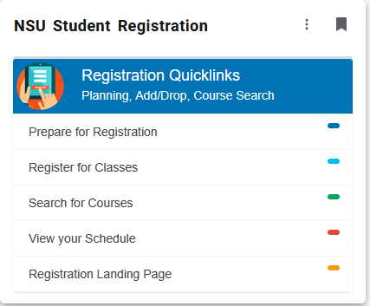

- Select the term that you are registering for (e.g.; Fall 2026). If you require an alternate pin, you will be prompted to enter it.
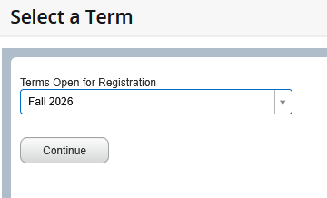

- If you already know your CRNs, tab over to “Enter CRNs.” If you do not know your CRNs, go to the “Add Classes by Searching” section of this document.

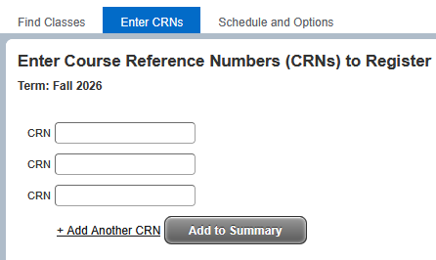

Option 1. Add Classes by Entering CRNs

- Once you have clicked on “Enter CRNs”, enter your CRN in the CRN box. If you have multiple classes, click on “+Add Another CRN.”
- When all of your CRNs are entered, click on “Add to Summary’. Your classes will populate in the lower right Summary box.
- Click “Submit” in the bottom right under the Summary box. Your class status should change from “Pending” to “Registered.”

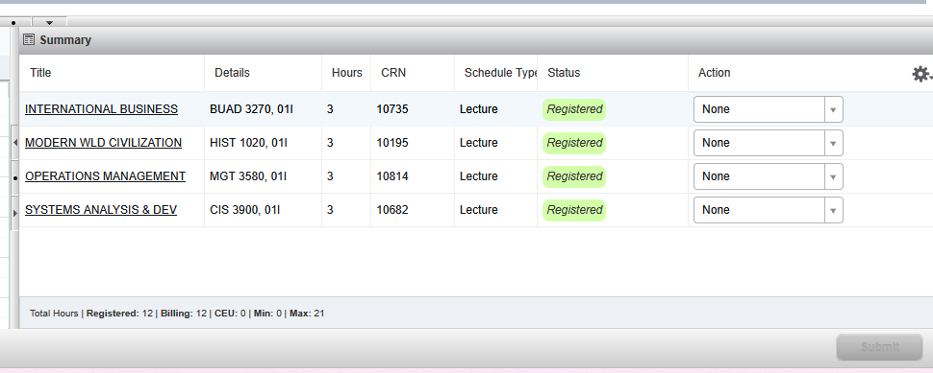

Option 2. Add Classes by Searching

- In the “Find Classes” tab, use the “Enter your Search Criteria” box to input the information for the course in which you wish to enroll. To start, click on the Subject box. You can enter your desired subject or browse the subjects offered this semester. If you know the course number (e.g.; ENGL 1020), that can help narrow down the options.

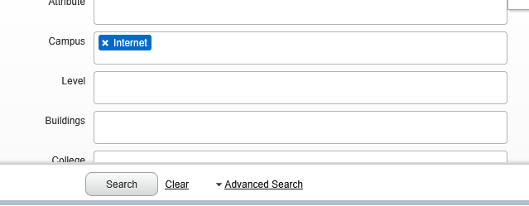
You can click on Advanced Search to help narrow down your options further. For example, to search for a face-to-face course in Natchitoches ONLY: Select your desired subject and then scroll down to “Campus” and click on the box. Select Natchitoches, then click “Search”. It will only show your F2F Natchitoches options.

- From the search results provided, find the open section in which you wish to register.
  - Be mindful of the days/times at which the section is being offered and ensure that you are not attempting to schedule two classes with overlapping times.
  - If a section is full or closed for any other reason, it will show “FULL” under Status.
  - Some courses may be restricted to students under that major or have prerequisites. Prerequisites and corequisites can be found by clicking on the course name in the leftmost column.

- Once you find your desired section, click the “Add” button on the right. It will add the course to your Summary box in the right-hand corner.
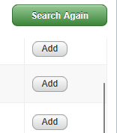

- To add another class, click on the green “Search again” button to start another class search.
- When your summary box is full of the classes you would like to register for, click “Submit” at the bottom of the page. Your class status will go from Pending to Registered.

- If you experience a registration error, please ask your academic advisor for assistance. Your course may require a permit or you may not have the necessary prerequisites to register.

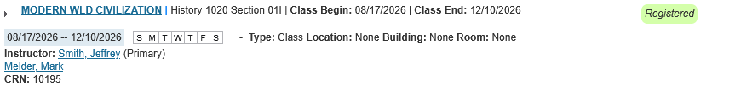You can find specific schedule details in the “Schedule Details’ section of the page.

If you wish to drop a course in which you are currently registered, navigate to your SUMMARY box and use the dropdown menu under the “Action” column in line with the course, and change the selection from “None” to “Drop”, then click the Submit button.

PRINTED COPY OF SCHEDULE FOR FRESHMAN CONNECTION
Navigate to the Schedule and Options tab and click the Printer icon in the top right. Print your schedule so that you can receive your student ID.

